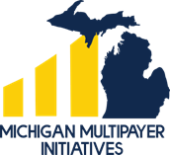

Increasing Primary Care Investment in Michigan

April 2026
For more information, contact Diane Marriott, DrPH (dbechel@med.umich.edu)

Contents
Executive Summary 3
The Primary Care Crisis in Michigan 4
A Better Path Forward: Strengthening Primary Care in Michigan 7
Increasing Investment in Primary Care 9
Paying Primary Care Differently 19
Moving from a Fee-for-Service to Hybrid Payment 19
Making It Easy for All Patients to Declare a Usual Source of Care 22
Ensuring that Increased Primary Care Revenue Flows to Primary Care Practice Teams 23
Adopting a Common Measure Set for Incentives 23
Recommended Actions to Strengthen Primary Care in Michigan 26
Implementation of Summary Recommendations 28

Executive Summary
Primary care serves as the foundation of a well-functioning healthcare system. It can point patients in the right direction to improve their health status, manage existing conditions, and spot problems before they become serious. Despite its benefits and criticality to patients, however, primary care is in crisis. Across the country, more than 35% of healthcare visits are provided by primary care physicians, yet they receive only 5% of health spending. As a result of this underfunding, there are long wait times to see a primary care provider and missed opportunities to manage preventable disease exacerbations. There is a more efficient and effective way to spend our health care dollars. By spending more on primary care, we increase its availability and its potential for preventing disease, managing conditions, improving population health, and reducing avoidable downstream costs.
Robust, widely available primary care is needed more than ever in Michigan. Even now, 25% of Michiganders lack a usual source of care. Looming losses in Medicaid coverage from the One Big Beautiful Bill Act (OBBA) and escalating premiums place an even greater strain on primary care. Without increasing resources flowing to primary care, physicians will be even less likely to choose a career in primary care, and those in practice will be even more challenged to serve patients.
More than a third of states have already passed legislation or enacted regulation to increase the percentage of spending that goes to primary care. Increasing investment in primary care in Michigan improves health outcomes and reduces avoidable costs. Research shows that only 5.6% of the health care dollar goes to primary care in Michigan and that 12 to 15% is needed for a strong primary care infrastructure. Legislation is needed in Michigan to require fully-insured plans health plans to spend at least 12% of total medical expenses on primary care legislation. In addition, self-insured, ERISA-exempt health plans and groups not subject to state regulation should work with their administrators to require that at least 12% of their total medical expenses are spent on primary care. In addition, health plans should transition the way that they pay primary care from fee-for-service (FFS) to hybrid payment with a portion of prospective payment. Finally, health plans should use a common attribution methodology and incentive measure set and work in multipayer collaboration to reduce administrative burden on primary care.
Michiganders deserve access to primary care that is sufficiently resourced. The state faces many tough choices, but increasing investment in primary care should not be one of them.

The Primary Care Crisis in Michigan
Michigan faces a host of healthcare challenges. In 2025, the cost of healthcare for a family of four in a typical employer-sponsored health plan was $35,119, up from $33,067 in 2024. Projections for 2026 are even more concerning, with predictions of an 8.5% group and 7.5% individual market increase. Increasingly Michiganders report skipping or delaying medical care due to costs. Since 2022, the Michigan healthcare market has also become increasingly consolidated within three systems, raising additional concerns that their concentrated market power may result in even higher prices.,
In Michigan today, one in five adults lack a usual source of care. The introduction of Medicaid Community Engagement Requirements and other aspects of the One Big Beautiful Bill Act (OBBA) will further erode access, increasing the number of uninsured Michiganders. Without a stronger primary care system, it is likely that this will increase avoidable emergency room and inpatient care.
In addition to Michigan’s affordability and access challenges, the population of the state is growing sicker. Rates of frequent physical distress, low birth weight, multiple chronic conditions and obesity rates in Michigan now exceed the national average. As well, the number of people with chronic diseases is climbing with younger ages of chronic disease onset nationally.
All of this is occurring as primary care clinicians, the first line of contact for patient concerns and linchpin of the system, are under-resourced, receiving the smallest share of the Michigan healthcare dollar (5 to 6%) though, like their peers nationally, they provide over 35% of the visits. To better understand how spending on primary care varies across the US, The Robert Graham Center and the Milbank Fund release an annual Primary Care Scorecard and Dashboard. The dashboard calculates the percent of spending on primary care office-based expenditures for primary care physicians (PCPs) defined as general practitioners, family physicians, general internists, geriatricians, and general pediatricians) for each state (i.e., the “narrow definition” of primary care spending). They found that in Michigan in 2022, the most recent year of available data, 5.5% of overall spending, 6.2% of commercial spending, 5.6% of Medicaid spending, and 3.4% of Medicare spending was on primary care, as shown in the following graph. These percentages are a far cry from the 12 to 15% that experts say is required to fund robust primary care.
% Primary Care Spending
Definition = Office-based expenditures for primary care physicians (PCPs) defined as general practitioners, family physicians, general internists, geriatricians, and general pediatricians)

Drawn from data in the 2025 Primary Care Scorecard Data Dashboard; Milbank Memorial Fund, Jabbarpour, et. al.

As a result, few physicians elect to pursue primary care. Of Michigan’s 83 counties, over 70 are designated by the Health Resources and Services Administration (HRSA) as Health Professional Shortage Areas (HPSAs), areas with more than 3,500 people for every one primary care provider. Research has established that in these areas, there are higher rates of emergency surgery, serious complications, and readmissions than in areas with better access to primary care.
It's not just HPSAs that face primary care workforce challenges. Researchers from the Robert Graham Center estimated that by 2030, Michigan will be short 862 primary care physicians overall, given the traditional model of care.
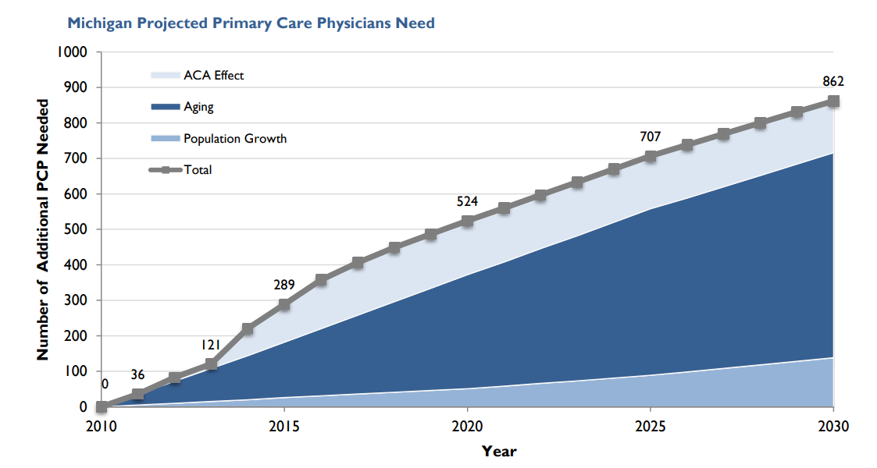
There is ample evidence that robust, evidence-based primary care is cost-effective and improves population health, reducing the burden of chronic disease, lowering healthcare costs, and delivering patient satisfaction., Further, Starfield, et. al. established that areas with higher ratios of primary care physicians to population have lower costs of care and better health outcomes.
Michiganders struggle to access and afford care. Insurers and employers face ever steeper healthcare spending, forcing them to consider less comprehensive benefit offerings and greater employee or member cost-sharing. There are too few primary care clinicians, and patients must wait weeks and sometimes months to see them. By the time that they do, patients are often sicker and harder to treat, and the cost of treatment is higher. If we do not take action to increase investment in primary care, we can expect even longer wait times for appointments, higher costs, more people without a usual source of care, and missed opportunities for preventing and managing chronic disease and more downstream costs.

A Better Path Forward: Strengthening Primary Care
in Michigan
Comprehensive, accessible primary care addresses issues early, promotes prevention, and partners with patients and caregivers to support chronic disease management and whole-person care. Studies demonstrate that high-quality primary care leads to better health outcomes and longer lifespans; it is also cost-effective.
A recent analysis of the eight largest provider organizations in Massachusetts found that provider organizations with high primary care investment as a percent of total spending performed significantly better on standardized measures than those with lower primary care investments as shown below.
Primary Care Spending and Quality in Massachusetts
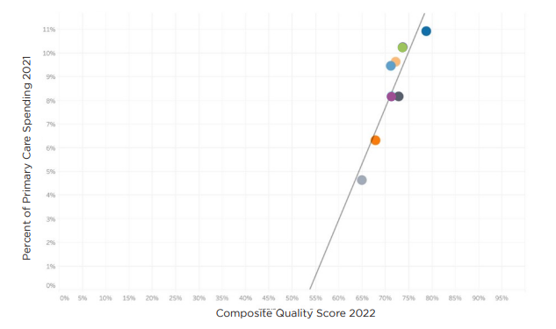
Note: The linear regression produced an R-squared value of .84 and a P-value of .001
Source: Analysis of Massachusetts: Primary Care Investment and Quality, Freedman Healthcare, July 2024

The same study also assessed the relationship between spending on primary care and hospital spending and found that organizations with higher investment in primary care experienced lower hospital spending as shown below. Though the predictive values were lower than in the quality analysis above, still , the findings illustrate the potential for primary care to stem avoidable inpatient care and emergency room visits.
Primary Care and Hospital Spending in Massachusetts

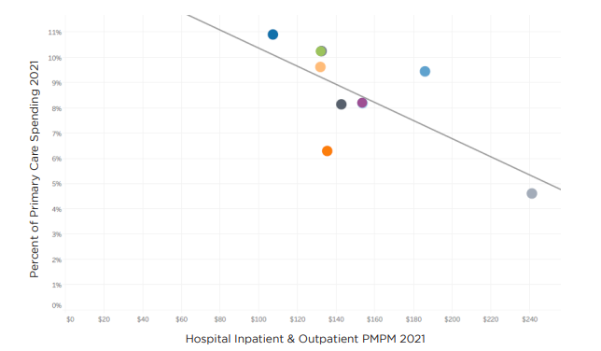
The linear regression produced an R-squared value of .50 and a P-value of .05
Source: Analysis of Massachusetts: Primary Care Investment and Quality, Freedman Healthcare, July 2024

Because primary care offers such great value and is so important to patient care, there is renewed activity nationwide to strengthen it. The National Academies of Science, Engineering, and Medicine (NASEM) 2021 report on Implementing High-Quality Primary Care: Rebuilding the Foundation of Health Care provides a robust set of principles and recommendations for improving primary care. It emphasizes an integrated, whole-person health model of care that is delivered by an interprofessional team that partners with patients. This interprofessional team is comprised of a primary care physician who leads a team of health care professionals (e.g., NP/PAs, RN Care Managers, other nurses, medical assistants, and additional ancillary staff such as social workers, community health workers, and pharmacists, etc.) that focus on each patient’s health needs to design a patient care plan.
This model is not new, but the current reimbursement model is insufficient to fund it. However, when it is utilized, the results are impressive. The model has been extensively studied and the workforce necessary to deliver it has been quantified. Meyers, et. al., used a combination of practice-level data from 73 practices and 8 site visits, and determined that to deliver high-quality primary care to 10,000 adults, a primary care practice needed about 37 full-time team members, including 6 physicians and 2 NPs or PAs, supported by a mix of nurses, medical assistants, and RNs and licensed clinical social workers to help manage those with more complex chronic needs. Other team members, such as a pharmacist, care coordinator, and office staff, were also included. For a 10,000-person panel with a larger proportion of geriatric individuals, the authors modeled a larger team with about 52 members, more devoted to complex care management. For a 10,000-person panel with high social needs, the team included about 50 members but relatively fewer physicians compared to the other models and with additional members, such as Community Health Workers (CHWs), behavioral health, and other social supports. The authors’ model for a smaller, rural panel of 5,000 included about 22 full-time team members, including a CHW.
The population of Michigan in 2025 is estimated at 10.14M. The number of primary care physicians practicing in Michigan is estimated at 6,852 physicians. Using Meyers’ ratio, if we adequately funded teams to provide high-quality primary care, we could do so with 6,084 full-time primary care physicians working with an interdisciplinary team that practiced at the top of their licenses, stretching the existing primary care workforce, capacity to cover the state. This model, with its increased resourcing of primary care, also has the additional benefit of attracting more medical students to pursue the field. This provides some hope that, with reasonable and rational reform, an improved primary care experience is within reach.
To strengthen primary care in Michigan, we need to increase investment in primary care and improve the manner in which we reimburse primary care.

Spending More on Primary Care
Spending more on primary care, with its focus on prevention and chronic disease, keeps people healthier and reduces the need for costly treatment down the road. To stem the erosion of primary care in Michigan and nationwide we must both increase investment in primary care and pay primary care services differently as emphasized in the NASEM Implementing High Quality Care report.
The Center for Medicare and Medicaid Innovation’s (CMMI’s) AHEAD demonstration is a federal model that increases investment in primary care as a part of a larger strategy to curb growth in overall health care costs, provide financial stability for hospitals, and support beneficiary connection to community resources. Six states (Maryland, Connecticut, Hawaii, Vermont, Rhode Island, and New York) participate in AHEAD so far. The model requires participation of the State, and a set of hospital partners. Thus far in Michigan, there has not been interest from the state or hospital partners in participating in AHEAD.

In addition, a growing number of states also have taken action at the state level to increase investment in primary care, including some of the AHEAD states. As shown below, about twenty states have enacted legislation or introduced bills to measure or increase primary care spending as a portion of total medical costs. Some have paired primary care investment reform with affordability or heath cost growth containment target legislation as a complementary measure.

States with Primary Care Investment Initiatives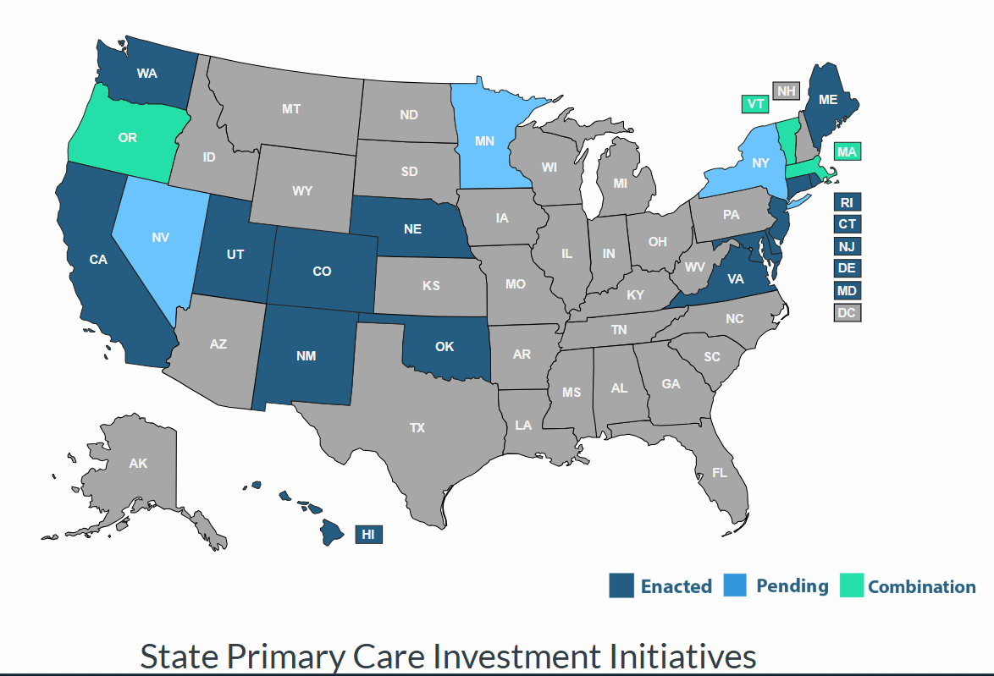
Source: https://archive.thepcc.org/primary-care-investment/legislation/map

Among the 40% of states that have taken action to measure and increase investment in primary care, tactics and approaches vary. For example, seven states have set primary care spending targets as follows:

- California
California’s Health Care Affordability Board approved two related primary care investment benchmarks in October 2024: 1) a statewide investment benchmark of 15% of total medical expense (TME) allocated to primary care for all payers by 2034; and 2) an annual improvement benchmark of 0.5-1 percentage point per year increase in primary care spending as a share of TME for each payer for years 2025-2033. The Office of Health Care Affordability (OHCA) measures and reports on primary care investment, with the first public reporting scheduled for 2026. Though the benchmark is not enforceable, the hope is that plans will voluntarily meet targets. California also has a statewide health care spending target, set at 3.5% for 2025 and phasing down to 3.0% for 2029, which is enforceable.. In addition, the state’s Medicaid program, Medi-Cal, increased rates for primary care services to 87.5% of Medicare rates, effective January 1, 2024.
- Connecticut
Connecticut has a 10% primary care spending target for commercial health plans, Medicare, and Medicaid, established by executive order in 2020 and codified into law in 2022. Executive Order No. 5 was passed in 2020 and required progressively increased spending on primary care to reach a target the 10% target by 2025. So far, however, the state has not met its primary care spending target, though the 2025 report has not yet been published.

- Delaware
Delaware’s history in state action to increase primary care investment dates back to 2018. Delaware has set a primary care target of 11.5% of total medical spending by 2025 for private insurers and a requirement to match Medicare reimbursement rates for primary care. However, a recent Delaware Primary Care Reform Collaborative strategic plan report expressed concern about the extent to which Medicaid and commercial payers are meeting their expectations. Members of the state’s Primary Care Reform Collaborative noted at their August 2025 meeting that the state is exploring participation in the federal AHEAD model as a promising long-term option.
- Oregon
Oregon’s strategy to increase primary care has been perhaps the nation’s most successful over time. In 2015, the state created the Primary Care Payment Reform Collaborative to study primary care spending and issue recommendations. SB 934 in 2017 required Oregon’s Coordinated Care Organizations and plans for public employees and educators to spend at least 12% of their total budget on primary care by January 2023. The state has impressive public-facing Oregon Primary Care Spending Dashboards that report the overall primary care spending rate for primary care at or above 13% of total medical spending for all lines of business (e.g., commercial, Medicaid, Medicare Advantage). The Oregon report cards show not only primary care spending as a percentage of total spending by plan type, but also the extent of non-claims spending on primary care and primary care spending by plan. Oregon also has a cost growth target program that set a 3.4% on cost growth for most payers. The overall cost growth targets ensures that increased investment in primary care will not be inflationary.

- Oklahoma
Oklahoma focuses its primary care investment actions on Medicaid spending. SB 563 directs the Oklahoma Health Care Authority to transition Medicaid from FFS to managed care and requires that 11% of spending to be spent on primary care by its Medicaid managed care organizations (MCOs) no later than the fourth year of a contract with the Medicaid program.
- Rhode Island
Rhode Island was the first state to adopt policies to increase primary care spending through its 2010 affordability standards, requiring commercial insurers to increase the share of health care spending allocated to primary care by 1% annually, while hospital price growth was capped at the Medicare price index plus 1%. The state required corrective action plans for meeting the primary care investment targets and included an enforcement mechanism to motivate improvement. Primary care spending subsequently increased, while total spending slowed, driven by hospital price growth caps. By 2018, 12.3% of spending by commercial insurers went to primary care, though upon further exploration the state found that the definition of primary care spending was overly broad and revised the definition to be narrower to address the root challenges for primary care. The new, narrower definition became effective beginning September 2024 and is set at a 10% target primary care spending of total medical spending .
- Washington
Washington State's primary care investment target, set by legislation (SB 5589), is set at reaching 12% of total healthcare spending on primary care. An advisory committee is working to define measures, track progress, and recommend strategies for payers (insurers, state plans) to meet this goal, aiming to shift away from fee-for-service towards team-based care. Current spending is significantly lower (around 6%), highlighting the need for increased investment, with some suggesting annual increases of 1-2%. The target is not enforceable and does not have a statutory enforcement mechanism (such as financial penalties or fines for non-compliance) for payers that fail to meet the goal. Instead, the state relies on voluntary measures, public reporting, and monitoring through the Health Care Cost Transparency Board.
Thirteen other states have introduced, but have not yet passed, primary care investment targets or have taken different kinds of legislative measures and state actions including measuring primary care spending to encourage investment in primary care. For example:
- Colorado
In Colorado, HB19-1233 established a Primary Care Payment Reform Collaborative that started meeting in July 2019 and has been extended until 2032. The Collaborative’s work includes measuring the percent of medical spending by plan. The legislation also requires commercial insurers to increase primary care spending by 1% in 2022 and another percent in 2023 and insurers are prohibited from raising premiums to cover the increased spending on primary care. The Collaborative uses Center for Improving Value in Health Care (CIVHC) Colorado data to track changes in primary care investment over time. They found that primary care spending across all reporting payer types has increased from 14.8% in 2022 to 15.7% in 2024, though it is uneven among payer types.

- Hawaii
In 2021, Hawaii required Medicaid Managed Care Organizations (MCOs) to report on and increase the percentage of medical expenditure devoted to primary care. This did not result in increased primary care spending due to pandemic-driven pressures and other challenges. However, Hawaii is an AHEAD state and this will increase primary care funding for participating practices. In addition, Hawaii's SB1646 introduced in 2025 requires the Hawaii Employer-Union Health Benefits Trust Fund Board of Trustees to negotiate with health insurance carriers to ensure that 12% of monthly premium payments are paid directly to primary care providers.

- Maine
In the fall of 2007, the Maine Legislature convened the Commission to Study Primary Care Practice to examine the issues facing primary care and ways to stabilize and support it. In the 2008-2009 State Health Plan, the Governor’s Office for Health Policy and Finance identified the need to promote primary care as the foundation for our state’s health system. The Maine Quality Forum issues annual reports, pursuant to Public Law 2019, Chapter 244. The most recent (November 20, 2025) report found that in the most recent year of reporting, 2023, primary care spending as a percentage of total payments was highest for MaineCare (11.6-12.7%), followed by Medicare (9.6%) and commercial payors (7.6%).

- Maryland
Maryland has a history of success in supporting primary care practices, often paired with or as a part of, larger reform efforts. For example, the state entered into a Total Cost of Care Model contr​act with the Federal Government designed to coordinate care for patients across both hospital and non-hospital settings, improve health outcomes, and constrain the growth of health care costs. A key element of the model is the Maryland Primary Care Program (MDPCP), a voluntary program open to all qualifying Maryland primary care providers that provides funding and support for the delivery of advanced primary care throughout the state. Advanced primary care is a comprehensive model that offers pharmacist, health and nutrition counseling, behavioral health, coordinated referrals and linkages to social services and support from health educators and community health workers to provide an integrated experience for patients. The state uses Care Transformation Organizations (CTOs) to allow practices to avail themselves of these resources without the need for direct investment. This allows prim​ary care practices to play increased roles in the prevention and management of chronic disease and the prevention of unnecessary hospital utilization. Public reporting has demonstrated that the MDPCP has contributed to decreases in Medicare total expenditures, as well as decreases in inpatient and emergency room utilization, all while maintaining budget neutrality. In addition to the MDPCP, Maryland will begin its implementation of AHEAD in January 2026 at which point MDPCP will become part of AHEAD in Maryland.

- Massachusetts
In December of 2025, the Massachusetts Primary Care Access, Delivery, and Payment Task Force released its first report, which recommended that a target for spending on primary care in Massachusetts be set at 15% of total healthcare spending, or double the current primary care spending share, whichever is greater, within five years of 2026. The Massachusetts Health and Hospital Association has released a statement saying that “Primary care is our most powerful tool for building healthier communities, easing the burdens on emergency rooms and caregivers, and connecting patients with the personalized services they need. We commend state leaders for giving primary care the close attention it deserves.” However, they also caution that a spending target would need to “be implemented in a meaningful, pragmatic, and collaborative manner – especially within the context of the growing pressures and current investments that exist within today’s delivery system.”

MassHealth, the state’s combined Medicaid and CHIP program, introduced primary care subcapitation for providers participating in MassHealth’s Accountable Care Organizations. This has increased investment in primary care and is an example of how states can use Medicaid in strategies to better fund primary care.

There is also a coalition of supporters in the state who are promoting passage of a suite of bills to support increased primary care investment. The PC4YOU effort promotes the passage of three different bills: 1) H.1370 (An Act Relative to Massachusetts Primary Care for You filed by Representative Rich Haggerty; 2) S.867 (An Act Relative to Primary Care for You filed by Senator Cindy Friedman); and 3) H.2537 (An Act Relative to Primary Care access filed by Representative Greg Schwartz).

In addition, Senator Friedman’s S. 750 was referred by the Senate to the Health Care Financing Committee but has not yet advanced. It includes the creation of a Primary Care Trust that would collect money from commercial payers as well as from other entities in Massachusetts that will be contributing to an increased investment in primary care. The Trust will distribute funds to primary care practices based on the Primary Care for You payment model as determined by the Primary Care Council and the Health Policy Commission. The Trust will have the capability of paying for efforts to support and train smaller practices engaging in primary care transformation. The Trust will also have the capability of paying for efforts to evaluate the savings in total medical expense in the Commonwealth that are generated by this legislation.

- Minnesota
Minnesota passed omnibus health legislation that requires a report on the proportion of total healthcare dollars invested in primary care and launched new primary care training and loan forgiveness programs along with investment in primary care-behavioral health integration. It has not to date, however, set a percentage target for primary care spending.
- Nebraska
On December 27, 2020, the federal Consolidated Appropriations Act, 2021, Public Law 116-260, became law in Nebraska which requires group health plans, health insurance issuers, and health insurance plans to provide data to the federal government on the total amount of spending on hospital costs; health care provider and clinical service costs, for primary care and specialty care separately; costs for prescription drugs; and other medical costs, including wellness services. It also establishes a Primary Care Investment Council to analyze the data collected by the federal government in accordance with the federal Consolidated Appropriations Act, 2021, and other data sources, to assist the Legislature in understanding the percentage of total healthcare spending spent on primary care. However, the council’s 2023 report notes that “ Our work as a council has been hampered by circumstances that are beyond our control, including the lack of data, managing administrative duties, and vacancies on the council.” Some in the primary care leadership community have turned their focus towards self-insured groups and employers to advance primary care.

- New Jersey
New Jersey requires Medicaid Managed Care Organizations to report the percentage of total medical expenditures devoted to primary care, as well as the State Department of Pension and Benefits to report on primary care spending for state-run health plans, such as the state employees’ plan. Though there is no statuary primary care spending target, a 2021 executive order set benchmarks for limiting overall health care cost growth, with targets of 3.2% for 2024 and 3.0% for 2025. The 2026 HealthCare Cost Growth Benchmark Report released in January 2026 by the state shows that statewide per person per year total health care expenditures increased by 6.1 percent between 2022 and 2023, exceeding the cost growth benchmark target of 3.5 percent by 2.6 percent. The report also includes per person spending by submarket for primary care spending, which shows a small increase from 2022 to 2023, the most recent data year available.
- New York
Senate Bill S1634 in New York requires health plans and payers to have a minimum of 12.5% of total medical expenditures on physical and mental health spending be spent on primary care services. The bill was introduced for the 2025-2026 legislative session, passed the New York State Senate, and is pending consideration by the State Assembly.

- New Mexico
Though New Mexico does not have a primary care spending target, New Mexico established a Primary Care Council in 2021 to monitor and analyze primary care spending on an annual basis. New Mexico’s Health Care Authority also announced that some Medicaid provider rates would increase to 120% of Medicare for some services, indirectly benefiting primary care.
- North Carolina
In 2023, North Carolina established a Primary Care Payment Reform Task Force (S. 259) to define primary care, assess current spending and issue recommendations. The goal is to establish a primary care investment target, with the goal of increasing investment to improve health outcomes and control costs, following national trends for 12-15% benchmarks.

- Utah
Utah has a Primary Care Spend Project operated within the Utah Department of Health’s Office of Health Care Statistics, which uses all payer claims data to calculate the total amount of spending on primary care as a percent of total medical expenditures. The 2023 report shows CHIP primary care spending at 9.5% for 2022 using a narrow definition of primary care spending, and 6.2% for commercial payers.

- Vermont
In 2019, Vermont passed legislation requiring the Green Mountain Care Board (GMCB) and the Department of Vermont Health Access (DVHA) to define primary care, measure spending, and develop methods to increase primary care investment, aiming for at least 12% of total healthcare spending, with goals to align Medicaid rates with Medicare, though there is not an enforcement mechanism. Additionally, the dissolution of a major health plan (OneCare Vermont) has challenged progress. Legislation has been introduced in the House and Senate however that is now under consideration that would set a target in state law that 15% of total health care spending in Vermont go to primary care, with the Vermont Medical Association encouraging passage.

There are five key lessons that can be drawn from the composite of efforts across the many states addressing increasing investment in primary care .

- Primary Care is In Crisis - The sheer quantity of states with initiatives to increase investment in primary care reflects concern about the primary care crisis nationwide. States are taking action to increase the percentage of spending that flows to primary care through legislation, rate review, state employee plan provisions and voluntary payer and purchaser-based initiatives to save the primary care infrastructure that patients depend upon.
- Definitions Matter - The way that primary care investment is defined is important and the narrow definition of primary care spending most closely addresses the root cause of inadequate primary care resourcing. Rhode Island, for example, revised its definition of primary care spending, effective March 20, 2025, to focus on payments to primary care sites that offer continuity in care, as well as addressing the movement to value-based or capitated payments:
“Primary care expenditures means all claims-based and non-claims-based payments by the health insurer directly to a primary care practice or integrated system of care for primary care services delivered to Rhode Island residents at a primary care site (excluding urgent care centers and retail pharmacy clinics). This includes claims-based payments for primary care services (defined using a set of taxonomy codes) and non-claims-based payments for capitated and prospective contracts, provider incentives, population health management, primary care practice infrastructure, primary care provider salaries, recouped payments due to reviews, audits, or investigations, and patient-centered medical home administrative expenses. Primary care spending is calculated by dividing this amount by total spending on all health care providers.”
- Sticks Over Carrots – Measurement alone is important but insufficient. It is difficult to command attention and action to increase primary care investment without a penalty or consequence for non-compliance. Unsurprisingly, the data also illustrates that efforts with consequences for not meeting targets are the most effective at achieving the aim of increasing investment in primary care as shown below.

Percentage of Health Care Dollars Invested in Primary Care
Selected States 2008-21
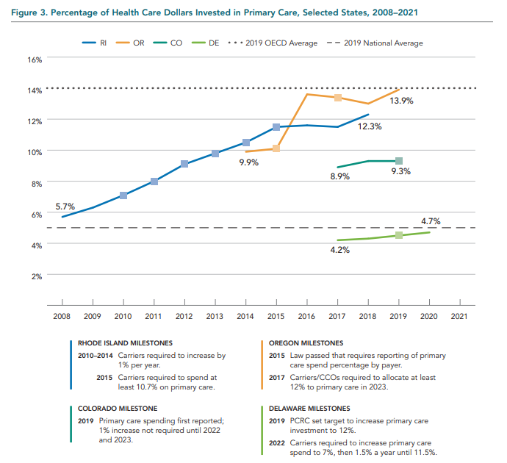
Source: Condon, M. J., Koonce, E., Sinha, V., & California Health Care Foundation. (2022). Investing in Primary Care: Lessons from State-Based Efforts. California Health Care Foundation Oakland, CA

The types of penalties or consequences vary across states. Some states have financial penalties for health plans who do not meet incremental primary care target spending levels. Others require corrective action plans. Some use rate review as a way to enforce compliance with primary care spending targets. Products subject to rate review would be subject to meeting the incremental target for full approval.
- Target Goal Amounts Converge Between 12 and 15% - The target goal range for the majority of primary care spending target initiatives is dedicating between 12 and 15% of total medical spending on primary care. To illustrate, in 2024, the national average per person spending on healthcare in the US was $14,570. Twelve percent (12%) of that amount is $1,748 or $145.66 per month.
- Importance of Self-Insured Groups and Trusts - In achieving a primary care spending target, employers, labor groups, trusts, and other purchasers are important stakeholders as state legislation applies only to fully-insured products and not to those who are self-insured and ERISA-exempt. However, self-insured groups can voluntarily replicate these provisions in their self-insured coverage designs (e.g., require that 12% of total medical spending goes toward primary care).

Paying Primary Care Differently
In addition to ensuring that primary care receives sufficient revenue to fulfill its promise, primary care should be paid differently. This requires moving primary care payment away from reliance on a fee-for-service backbone and toward a hybrid method of payment that blends some prospective payment with portions that are retrospective and incentive-based. Preferably plans would adopt a common hybrid payment method to reduce confusion and increase transparency. In addition to a common hybrid payment method, plans should ask all members to declare their choice of primary care provider and use a common attribution methodology to link a patient with a provider when the patient elects not to select a primary care provider. Finally, there should be protections for primary care practices so that the hybrid payment goes to the primary care practice team delivering the care and is not retained by their parent system or organization.

Moving from a Fee-for-Service to Hybrid Payment
In addition to paying primary care a larger share of total medical spending, the National Academy of Science, Engineering, and Medicine’s (NASEM’s) Implementing High Quality Primary Care report calls for payers to pay for primary care differently. Most primary care services are paid via fee-for-service (FFS) reimbursement. However, effective, efficient primary care includes a compendium of services that are not well-recognized in the FFS system.

Hybrid payment shifts away from a reliance on FFS payment and toward a payment system that is made up of three parts: 1) a prospective portion so that practices have the immediate funding that they need for staffing and population health management; 2) a portion to fund incentives for desired outcomes; and 3) a portion for things that are high-value or under-provided (e.g., immunizations). This system moves away from reliance on the FFS system and toward a combination of prospective payment for primary care that pays for primary care teams to care for people. The existing fee-for-service structure, even when paired with retrospective incentives and uplifts is poorly equipped to provide primary care with the dollars needed to fund care teams so that they are available to care for a panel of patients.
Switching from FFS-based primary care payment to payment that is fully based on prospective capitation with retrospective reconciliation on the other hand, may impose greater risk than many practices can bear. A middle ground that has emerged as a better way to pay primary care is a hybrid method that combines a portion of payment that is prospectively paid, population-based and risk-adjusted to provide practices with the resources to operationalize robust care management and population health. Face-to-face (whether in-person or virtual) visits can be paid either on a Per Member Per Month (PMPM) basis or on a per-visit basis. A third incentive-based portion would motivate person-centered, value-based outcomes and performance, as the model must deliver benefit to patients and value for health care dollars received. This incentive-based portion should be developed in partnership with health plans through multipayer and state collaboration so that clinicians are not additionally burdened by varying requirements across plans.
CMS is helping to pave the path toward hybrid primary care payment. In 2025, CMS initiated a new set of Traditional Medicare codes called Advanced Primary Care Management (APCM) services that pay providers a risk-adjusted per member per month amount that helps to provide revenue so that practices can resource their practice teams to meet the needs of patients. These APCM codes are risk-adjusted bundles that resource practices prospectively and with low administrative burden for delivering advanced primary care services to patients. CMS created three levels based on patient complexity ranging from patients who have zero chronic conditions to those who are complex Qualified Medicare Beneficiaries). These codes are G0556 for patients with zero or one chronic conditions, G0557 for those with two or more, and G0558 for Qualified Medicare Beneficiaries (QMBs) with two or more chronic conditions. The codes cover a range of advanced primary care management services including:
- Principal care management (PCM) – disease-specific services to help manage a patient’s care for a single, complex chronic condition that puts them at risk of hospitalization, physical or cognitive decline, or death
- Transitional care management (TCM)
- Chronic care management (CCM)
- Communication technology-based services including virtual check-ins, remote evaluations of pre-recorded patient information, and interprofessional consultations
The codes are not time-based, thus reducing administrative burden. Physicians can bill the monthly APCM code for all patients in their panel who consent to receive the services. In this way, the APCM code mimics the prospective portion of hybrid primary care management payment. However, the APCM codes are subject to the 20% cost-sharing required in Traditional Medicare. Though the majority of Traditional Medicare patients have a Medicare supplemental (”Medigap”) policy, about a tenth of Traditional Medicare patients do not and face financial liability for APCM services, making practices hesitant to bill them.
This patient's financial liability for non-face-to-face services imposes a barrier to patient engagement and as a result, the codes are used by only a small share of primary care clinicians. This is true even in Michigan where most commercial and Medicaid plans waive patient cost-sharing for care management. Commercial and Medicaid plans use a variety of other fee-for-service codes and uplifts to pay for individual care management services.
However, CMS’ APCM codes set a good example for how commercial and Medicaid payers could structure prospective funding to enhance primary care practice teams and resources. Wherever possible, such plans should waive or eliminate member cost-sharing. This allows for a practical way to achieve implementation of hybrid primary care payment across Michigan and provide sufficient prospective payment for practices to better serve patients.
Payers in other states have already begun to replicate CMS’ APCM codes to hybrid payment approaches for their other lines of business. For example, the California Advanced Primary Care Initiative (CAPCI), a joint effort of the California Quality Collaborative (CQC), a program of the nonprofit coalition Purchaser Business Group on Health (PBGH) and the Integrated Healthcare Association (IHA), has created a multipayer partnership in the commercial market to enable primary care practice transformation. The participating plans, Aetna, Blue Shield of California, and Health Net, blend capitation (per-member-per-month) with fee-for-service (FFS) and performance incentives, aiming to boost investment, improve quality, and support team-based care for better outcomes, with plans extending to public programs like CalPERS and Medi-Cal. This approach to hybrid payment includes:
- Monthly per member per month (capitated) payment
- Volume-based payment for specific pre-defined services (focusing on preventive care)
- Population health management payment to support practice improvements that will deliver better outcomes
- Incentives for strong performance on a common set of outcomes measures.
Blue Shield of California has been particularly active and is considered a national leader in implementing primary care hybrid payment They are operationalizing a demonstration and have begun to convert primary care payment to a hybrid model.
In addition, PBGH, one of the most influential purchaser voices in the nation, has released an Employer Health Plan Common Purchasing Agreement for Advanced Primary Care, outlining eight principles that purchasers can incorporate into their contracts with health plans.

Making It Easy for All Patients to Declare a Usual Source of Care
Integrated, whole-person, patient-centered primary care requires that patients have access to a responsive primary care practice. The practice receives the hybrid primary care payment for the patients attributed to them. Often only in HMO models are patients asked to select a primary care provider. In other types of plans, the standard method for assigning attribution is usually an algorithm based on plethora of evaluation and management codes in a prior period (e.g., two years). This approach discounts the patient’s ability to express their preference of the primary care provider of their choice. To improve upon this, members in all plan types (e.g., traditional, PPO, POS, HMO, etc.) should be asked to declare their choice of a primary care provider upon enrollment and annually thereafter.
The attribution algorithm used when patients do not elect a primary care provider of choice should be common across payers to reduce provider administrative burden.

Ensuring that Increased Primary Care Revenue Flows to Primary Care Practice Teams
There has been a steady decline in the number of independent primary care physicians over time. The American Medical Association estimates that in 2025, only 30 to 40% of primary care physicians worked in independent practices as practices have been purchased by, or merged with, hospitals, health systems, and large corporate entities. As a result, instead of independent practices being paid, now systems and large organizations bill and are the recipients of payment.
The NASEM report emphasizes the importance of payment flowing to practices so that they can hire the staff and make the investment to better prepare their practice for providing whole-person, integrated care. When investment in primary care is increased and payment goes to systems or physician organizations affiliated with primary care practices, and not to the practice itself, absent an express commitment to flow funding, there is a danger that the funding is diverted and absorbed by the organization. To guard against this, some programs cap the amount that entities can retain for administration and overhead. In the Michigan Primary Care Transformation demonstration, for example, organizations (health systems, physician organizations, etc.) were required to flow down at least 80% of primary care demonstration payments to participating practices, and to use no more than 20% of primary care demonstration payments for administration and overhead.
Voluntary compacts are another way to encourage increased funding is passed through to primary care practices. Organizations would thus sign on to the compact and commit to passing along the majority (e.g., at least 80%) of primary care funding to primary care practices. Employers, labor groups, trusts, and other purchasers of care could be useful allies in communicating this information to their members so that they can consider it when they declare a usual source of care.

Adopting a Common Measure Set for Primary Care Incentives
The cacophony of performance incentive metrics among payers confuses primary care clinicians and makes it difficult for them to understand which metrics they should employ, as their panels are comprised of patients with coverage from many different health plans. Therefore, in the work to strengthen primary care by increasing investment in it, a common measure set should be adopted by all plans to assess performance and award incentives.
The noise in the system created by the multitude of quality metrics has been recognized to be a problem by CMS as well. CMS has created The Universal Foundation, a set of high-priority quality measures that they have begun to deploy across CMS programs. Importantly, CMS has also indicated that it will prioritize these for digitization. The Universal Foundation is comprised of a streamlined set of adult measures and a set of child measures as follows:
Universal Foundation Adult Measures
Domain | Measure Identification Number and Name
Wellness and prevention | 139: Colorectal cancer screening  93: Breast cancer screening  26: Adult immunization status
Chronic conditions | 167: Controlling high blood pressure  204: Hemoglobin A1c poor control (>9%)
Behavioral health | 672: Screening for depression and follow-up plan  394: Initiation and engagement of substance use disorder treatment
Seamless care coordination | 561 or 44: Plan all-cause readmissions or all-cause hospital readmissions
Person-centered care | 158 (varies by program): Consumer Assessment of Healthcare Providers and Systems overall rating measures (CAHPS)

Universal Foundation Child Measures
Domain | Measure Identification Number and Name
Wellness and prevention | 761 and 123: Well-child visits (well-child visits in the first 30 months of life; child and adolescent well-care visits)  124 and 363: Immunization (childhood immunization status; immunizations for adolescents)  760: Weight assessment and counseling for nutrition and physical activity for children and adolescents  897: Oral evaluation, dental services
Chronic conditions | 80: Asthma medication ratio (reflects appropriate medication management of asthma)
Behavioral health | 672: Screening for depression and follow-up plan  268: Follow-up after hospitalization for mental illness  264: Follow-up after emergency department visit for substance use  743: Use of first-line psychosocial care for children and adolescents on antipsychotics  271: Follow-up care for children prescribed attention deficit-hyperactivity disorder medicine
Person-centered care | 158 (varies by program): Consumer Assessment of Healthcare Providers and Systems overall rating measures (CAHPS)

Alternatively, a measure set could be adopted that mimics that used by the California self-insured groups participating in PBGH’s hybrid payment program.

Purchaser Business Group on Health 2025 Advanced Primary Care Measure Set
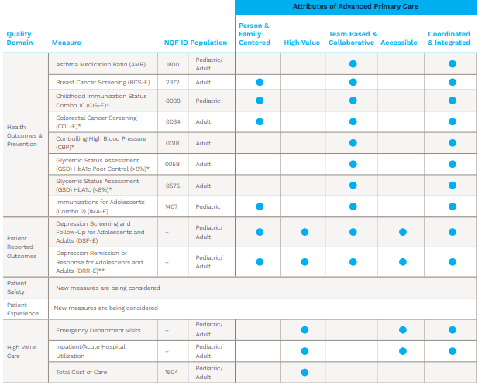

Recommended Actions to Strengthen Primary Care
in Michigan
It is clear that we must increase our investment in primary care more and change the way that we pay for primary care. Given the urgent need to reform primary care payment in Michigan and incorporate learnings from the more than twenty states that have already taken action to increase primary care investment, the following five summary recommendations are needed in Michigan.

RECOMMENDATION 1: Pay primary care more by passing legislation to require health plans to spend at least 12% of overall medical expenditures on primary care using the narrow definition of primary care spending) as a portion of total medical spending.

RECOMMENDATION 2: In implementing the 12% primary care spending target, all payers (Medicaid, commercial, Medicare Advantage, fully-insured, self-insured, etc.) should transition their primary care payment approaches to primary care hybrid payment with a common approach to incentive measurement and attribution.

RECOMMENDATION 3: All payers (Medicaid, Medicare, commercial insurers, and self-insured employers) should ask all covered individuals to declare a usual source of primary care annually. Payers should agree on a common attribution methodology that prioritizes a member’s choice of primary care provider. All payers should agree upon and use a common attribution methodology for non-responding enrollees to attribute them to a primary care provider.

RECOMMENDATION 4: Encourage Systems, Physician Organizations, and Similar Entities That Serve as Contracting Vehicles for Primary Care Physicians to Sign On to a Voluntary Compact to Flow Resources to the Practice Level

RECOMMENDATION 5: Utilize a common set of primary care metrics across health plans in Michigan.

In actualizing the five recommendations specified above, there are several natural advantages to Michigan that should be leveraged and will ease the path toward more sustainable and better performing primary care. Chiefly, that:
- Michigan has a robust network of physician organizations that support primary care practices and that can serve to support their success in transitioning to primary care hybrid payment;
- The majority of Michigan primary care practices have attained Patient-Centered Medical Home (PCMH) designation, and large payers such as Blue Cross Blue Shield of Michigan have begun to encourage practices to achieve Advanced Primary Care Management (APCM) designation.
- CMS has introduced Advanced Primary Care Management (APCM) codes into the Physician Fee Schedule in 2024 that establish a way to catalyze the transition from fee-for-service billing toward hybrid primary care payment. These codes pay practices a monthly fee to provide care proactively and remotely, including the non face-to-face coordination so pivotal to patient optimization. There are three different codes - G0556 (Level 1), G0557 (Level 2), and G0558 (Level 3) - based on the patient's health complexity from a patient with no chronic illnesses to a patient with many complex chronic conditions. Because CMS Physician Fee Schedule codes are often adopted by commercial, Medicaid, and Medicare Advantage plans, they provide a path to implementation and underscore CMS’ recognition of primary care’s contribution to patient health.
- Michigan payers were early supporters of physician-directed care management and have waived patient-cost sharing across product lines wherever possible to encourage patient engagement.
Primary care is the building block of the healthcare system and we are failing it. Robust primary care prevents unnecessary specialty care, imaging, and hospital use where possible, yet we under-resource primary care and cripple its potential to contribute to an affordable and effective healthcare system. Though we face many difficult choices, increasing investment in primary care should not be one of them.

Implementation of Summary Recommendations
To implement these primary care payment reform recommendations and to ensure they are sustained over time, a Michigan Primary Care Investment Coalition (“the Coalition”) will be convened with representation from experts in primary care and population health including practicing physicians, health plans, multipayer conveners, state government, and academic partners, along with patients, employers, organized labor, and other stakeholders.
The Coalition will be launched by an Organizing Group who will facilitate meetings and support the Coalition’s success. The Organizing Group will provide a framework and guidance for the Coalition which will work to optimize and operationalize the summary recommendations in this report by:
1. Agreeing on a Shared Vision, Strategy, and Action Plan
- Review the recommendations in this report, refining and improving them where possible, as well as the methodological issues including:
  - Primary care investment proposed definition (narrow vs. broad)
    - Document currently uses the Graham Center’s narrow definition of primary care spending (outpatient and office-based expenditures to PCPs only)
    - Alternative is the broad definition (includes the narrow definition as well as spending for office-based care from NPs, PAs, behavioral health clinicians, and obstetricians/ gynecologists)
  - Data source for ascertaining future spending on primary care in Michigan
    - Payer reporting of spending percentages to state
    - Payer requirement to submit files annually to Department of Insurance and Financial Services (DIFS) at MDHHS
    - Use of external data (e.g., Milbank/Graham Center Primary Care State Scorecards)
  - NP/PA clinician role and inclusion and use of terms (e.g., clinician, provider, etc.)
- Consider a business case and value proposition for policymakers and payers
- Finalize a shared vision, strategy, and action plan
2. Create Key Messages Documents

- Key messages summary
- Infographic
- Take-away piece

3. Conducting Political Mapping and Recommendation Stress-Testing to Refine Action Plan and Key Messages
- Assess allies and supporters and conduct outreach, including bipartisan legislative champions
- Identify groups who may oppose the recommendations, consider their perspectives, and assess the potential for codesign in the interest of patients and affordability
- Conduct listening and outreach sessions with primary care practices and clinicians to incorporate their perspectives
- Refine action plan and key messages

4. Formulate a Tactical Workplan with Timebound Milestones
- Identify key milestones and time-bound tactical workplan, assigning accountability for tasks to Coalition partners
- Identify any resource needs and work to acquire support and funding where needed

5. Drafting Legislative, Contractual, and Voluntary Compact Language
- Draft bill language: Write text or refine existing proposed bill language leveraging learning from partner state legislative language; Consider a budget line item in the upcoming State of Michigan budget to support implementation (e.g., data acquisition and management, meeting support, etc.).
- Draft voluntary compact language: Draft language for voluntary compact that systems and physician organizations sign to demonstrate their commitment of flowing at least 80% of funds to primary care practices
- Draft sample contractual language: Write proposed language for payers to adopt in their provider contracts (e.g., use of common, multipayer incentive metrics, etc.)
6. Adoption and Implementation via Stakeholder Engagement
For legislative actions:
- Present the proposal: Introduce the drafted policy to the legislature for consideration.
- Navigate the legislative process: Advocate for adoption of recommendations; support committee hearings, debates, and votes in both chambers of the legislature.
- Build support: Work to gain co-sponsors, lobby other lawmakers, and mobilize public support to increase the chances of passage.
For voluntary compact and draft contractual language:
- For voluntary compact:
  - Develop common boilerplate voluntary compact language for systems and Physician Organizations (POs) to flow funds down to primary care practices
  - Meet with system and PO partners to introduce the voluntary compact to ensure funding flow to primary care practices
- For draft contractual language:
  - Develop common boilerplate draft contractual language for fully-insured employers and groups to require their administrators to spend at least 12% of total medical expenditures on primary care
  - Meet with payer leaders to discuss the draft contractual language

7. Support Capacity of Physicians and Practices to Deliver Advanced Primary Care Management and Team-Based Care
- Design Common Outcome and Accountability Measure: With health plans, identify and commit to a common measures across plans for incentive portion of hybrid payment
- Enable Shared Learning Among POs and systems to support practice change

8. Develop a Public-Facing Dashboard and Coalition Website to Encourage Transparency and Stakeholder Engagement
- Create and publicize a website: So that there is easy access to key messages, a website should be created akin to Massachusetts’ Primary Care for You (PC4YOU) site
- Annual progress reviews: Review action taken, progress made, barriers and challenges identified, etc. Incorporate assessment by external experts.
- Make adjustments: Incorporate modifications and update as needed

For more information, contact Diane Marriott, DrPH, Director of Michigan Multipayer Initiatives, at(dbechel@med.umich.edu

Foubister V. Five States Leading Efforts to Increase Primary Care Spending. The Milbank Memorial Fund. March 12, 2025
Bell, et. al., 2025 Milliman Medical Index, May 27,2025
PWC, Medical Cost Trend: Behind the Numbers 2026, July 16, 2025; https://www.pwc.com/us/en/industries/health-industries/library/behind-the-numbers.html
Altarum August 2025 Healthcare ValueHub Brief; https://healthcarevaluehub.org/wp-content/uploads/2025-Michigan-Affordability.pdf
https://www.kff.org/health-costs/ten-things-to-know-about-consolidation-in-health-care-provider-markets/
https://files.gao.gov/reports/GAO-25-107450/index.html#:~:text=urologists%20in%20Indiana.-,Studies%20Indicate%20Physician%20Consolidation%20Can%20Increase%20Spending%20and%20Prices;%20the,type%20on%20access%20to%20care.
Jabbarpour, Y., Jetty, A., Byun, H., Siddiqi, A., & Park, J. (2025). The Health of US Primary Care 2025 Scorecard: The Cost of Neglect (Report). Milbank Memorial Fund & The Physicians Foundation. DOI: 10.1599/mmf.2025.0218
America’s Health Rankings 2024 Annual Report
Watson KB, Wiltz JL, Nhim K, Kaufmann RB, Thomas CW, Greenlund KJ. Trends in Multiple Chronic Conditions Among US Adults, By Life Stage, Behavioral Risk Factor Surveillance System, 2013–2023. Prev Chronic Dis 2025;22:240539. DOI: http://dx.doi.org/10.5888/pcd22.240539
https://www.healthaffairs.org/doi/abs/10.1377/hlthaff.2023.00843?journalCode=hlthaff
Michigan: Projecting Primary Care Physician Workforce, Robert Graham Center, accessed at https://www.graham-center.org/content/dam/rgc/documents/maps-data-tools/state-collections/workforce-projections/Michigan.pdf
Foubister V. Five States Leading Efforts to Increase Primary Care Spending. The Milbank Memorial Fund. March 12, 2025.
https://www.chcf.org/wp-content/uploads/2022/04/InvestingPrimaryCareWhyItMattersCommercialCoverage.pdf
B. Starfield, et. al., Contribution of Primary Care to Health Systems and Health, Milbank Quarterly, 2005 Sep;83(3):457–502. doi: 10.1111/j.1468-0009.2005.00409.x
Implementing High-Quality Primary Care, National Academies of Sciences, Engineering, and Medicine; Health and Medicine Division; Board on Health Care Services; Committee on Implementing High-Quality Primary Care; Washington (DC): National Academies Press (US); 2021 May 4. ISBN-13: 978-0-309-68510-8ISBN-10: 0-309-68510-9
Implementing High-Quality Primary Care, National Academies of Sciences, Engineering, and Medicine; Health and Medicine Division; Board on Health Care Services; Committee on Implementing High-Quality Primary Care; Washington (DC): National Academies Press (US); 2021 May 4. ISBN-13: 978-0-309-68510-8ISBN-10: 0-309-68510-9
Meyers, D., L. LeRoy, M. Bailit, J. Schaefer, E. Wagner, and C. Zhan. 2018. Workforce configurations to provide high-quality, comprehensive primary care: A mixed-method exploration of staffing for four types of primary care practices. Journal of General Internal Medicine 33(10):1774–1779.
https://www.michigan.gov/mcda/population/michigan-population-analysis
The State of Primary Care Workforce: Michigan, Robert Graham Center, 2018
https://www.milbank.org/publications/states-lead-efforts-to-increase-primary-care-spending/
Pollack, AA, Ricci, DA, Song, Z, Sullivan, EE, Grumbach, K, Cohen, DJ, and Phillips, RS (December 18, 2025). The Primary Care Investment Guide, Primary Care Collaborative
https://hcai.ca.gov/affordability/ohca/promote-high-value-system-performance/primary-care-investment-benchmark/
https://legis.delaware.gov/BillDetail/68714
https://dhss.delaware.gov/wp-content/uploads/sites/4/2025/02/pcrcstrategicplanrpt24.pdf
https://www.milbank.org/publications/states-lead-efforts-to-increase-primary-care-spending/#:~:text=OHIC%20also%20plans%20to%20implement,'%E2%80%9D
https://www.chcs.org/resource/massachusetts-primary-care-sub-capitation-model-implementing-primary-care-population-based-payment-in-medicaid/
https://www.milbank.org/publications/states-lead-efforts-to-increase-primary-care-spending/#:~:text=OHIC%20also%20plans%20to%20implement,'%E2%80%9D
Why Are Americans Paying More for Healthcare?; Peter G. Person Foundation, August 12, 2025.
National Academies of Sciences, Engineering, and Medicine. (2021). Implementing High-Quality Primary Care: Rebuilding the Foundation of Health Care.
https://www.blueshieldca.com/content/dam/bsca/en/provider/docs/2025/primary-care-pay-for-value-hybrid-payment-model-manual.pdf
https://www.cms.gov/medicare/quality/cms-national-quality-strategy/universal-foundation
Advanced Primary Care Measure Set, February 2025, Integrated Healthcare Association and California Quality Collaborative
https://www.cms.gov/medicare/payment/fee-schedules/physician-fee-schedule/advanced-primary-care-management-services

