May - June 2024

Michigan Multipayer Initiatives (MMI) convenes payers, practices, Physician Organizations and community stakeholders to lead the transformation of primary care and improve care value, equity, quality, and patient experience in Michigan. To be added to our distribution list, send an email with “Add Me to Newsletter Distribution '' in the subject line to multipayerprimcare@med.umich.edu. Our website is at https://mimultipayerinitiatives.org/. To share an idea or ask a question, please contact Diane Marriott (dbechel@umich.edu or 734 740 0511).

Just Issued! Updated 2024 Multipayer SDoH Incentives Table
Wondering about how payers in Michigan are approaching the new social care integration codes that CMS introduced in FFS Medicare at the beginning of the year? The newest update of the provides the latest information plan by plan. Multipayer SDoH Incentive Table provides the latest information plan by plan.
As more attention is directed at the integration of social care and health care, and regional hubs take off across the state, there is increased interest and potential in how SDoH incentives fit into the blending and braiding of funding to sustain integration efforts. That’s why the newest version of the Multipayer SDoH Incentives Tables also includes how plans are approaching the new CHW reimbursement codes.
Michigan payers are ahead of payers in many other states. For example, some payers offer incentives for participating in MiHIN’s SDoH Use Case. It is important to keep in mind that these are relatively new codes and it will take time for providers to incorporate them in workflows.

Michigan Multipayer Initiatives Presents at the National Academy’s Standing Committee on Primary Care in Washington
We were delighted when the National Academy of Medicine invited Michigan Multipayer Initiatives to their May 20-21 meeting in Washington DC to share recommendations for improving federal primary care policy. Diane Marriott, DrPH, presented on lessons learned from the history of multipayer primary care demonstrations in Michigan, and thoughts for CMS and CMMI’s consideration in formulating ongoing approaches. You can see all the sessions from the meeting as well as the speaker slide decks at https://www.nationalacademies.org/event/42471_05-2024_standing-committee-on-primary-care-may-meeting. For extra credit, the presentation from Michigan is in Segment Two of the Day One proceedings.
The meeting was one in a series catalyzed by the National Academy of Science, Engineering and Medicine’s (NASEM’s) landmark Instituting High-Quality Primary Care issued in 2021. Since then it has been lauded as a roadmap to supporting success for primary care and the patients it serves. The report reminds us our focus should be on teams delivering whole-person care and the importance of reformulating payment for primary care so that a portion is paid prospectively for each patient attributed to a practice so that they can do the real work of comprehensively meeting patient needs and keeping people well.
Just issuing a report doesn’t get the job done, and NASEM’s Standing Committee on Primary Care focuses on catalyzing forward movement and engaging with federal agencies, non-governmental stakeholders, and other experts to wayfind solutions to the most pressing issues in primary care financing, payment, and access.
The work doesn’t end here. It takes all of us working together to improve care delivery, integration of social care servicing, transform payment to primary care practices, and support patients and caregivers. It’s a big job and we’ve made some real progress together, but there is so much more to do to make the aspirations of the Implementing High Quality Primary Care report become fully realized in Michiganders.

Are Your Ready for MiHIN’s SDoH Use Case V.4 Rollout?
It’s always good to have a plan for the future. Many participating organizations in MiHIN’s Social Determinants of Health (SDoH) Use Case (Social Need Screening data) already have a plan and are preparing to convert to Specification v4 by the required deadline, December 20th, 2024. If you participate or plan to participate, and you haven’t yet met with your IT partners, it’s a good time to reach out to them so you’ll be prepared and ready. The October 2023 editions of MiHIN’s Bit’n’Bytes and Download have the full detail.
In brief, version 4 (v4) has a number of advantages over previous versions. It refines fields to simplify and clarify data requirements which will make validation easier and is structured to maximize consistency with the HEDIS Social Needs Screening and CMS’ SDoH Risk Assessment code requirements including:
- Only allowing codified/validated and approved screening tools/ questions (i.e. tools that link to LOINC codes)
- Using additional fields to increase matching capabilities. In addition to first name, last name, DOB, and sex, at least one of the following must also be included: Phone Number; SSN4, or Address.
MiHIN will begin onboarding organizations using this specification in July of 2024. The deadline for converting to the v4 file specification is December 20th, 2024 to avoid interruption to a participating organization’s submissions. Starting January 1, 2025th, no other file specifications will be accepted.
If you have questions, MiHIN’s Cross Sector Data Sharing Program Director, Lisa Nicolaou leads this work and is happy to help.

Senators Whitehouse, Cassidy Introduce Legislation to Implement Hybrid Primary Care Payment in the Physician Fee Schedule
U.S. Senators Sheldon Whitehouse and Bill Cassidy, M.D. have introduced legislation to reform how primary care providers get paid through Medicare. Whitehouse, a Democrat from Rhode Island, and Cassidy, a physician and Republican from Louisiana, introduced a bipartisan bill, the Pay PCPs Act (S. 4338), Wednesday to better support and improve pay for high-quality primary care providers.
The bill would also provide Medicare beneficiaries with reduced cost-sharing for certain primary care activities and service and would also create a new technical advisory committee to help CMS more accurately determine Fee Schedule rates. The proposed legislation would encourage CMS to accelerate its existing efforts to support value-based primary care and improve the adequacy of pay for primary care providers in Medicare, according to the lawmakers.
The bill was just introduced on May 15th, so it’s too early to tell if “has legs.” Still it shows us a workable way to grapple with some of the trick implementation issues (e.g., which services to include in the prospective payment portion; etc.)


THE TRAINING CORNER
To better serve you, we have expanded the array of care management and team-based training sessions. We are fortunate to have MiCMT, Mi-CCSI, MiCHWA, IHP, PTI, MyMichigan Health and our newest addition Health Net of West Michigan to provide expert training on important topics in primary care. Here is a summary of their upcoming training sessions.



Michigan Institute for Care Management and Transformation (MICMT)

MICMT is excited to announce Medication Reconciliation training, led by Dr. Nada Farhat, PharmD, BCPS, BCACP. This training will focus on medication reconciliation best practices across multiple care team settings, including primary care, specialty, care management focused visits, and transitions of care. The 2-day training Optimizing Medication Reconciliation: Role of Care Team Members will be held on, Tuesdays, July 16th & 23rd at 11 am – 1 pm and it is open to all members of the practice. To learn more, please visit the Medication Reconciliation Training Info Page. Early registration will ensure that you receive timely reminders and Zoom links!
Please be sure to check MICMT’s event calendar to view a list of upcoming trainings, including live webinars or at a glance view please find the event calendars and event flyers in the “news” section here. Questions and concerns can be shared at https://micmt-cares.org/contact.

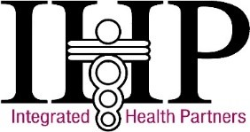
Integrated Health Partners (IHP)

IHP offers an array of trainings throughout the year. This includes Introduction to Team Based Care, Patient Engagement, and Foundational Care Management Codes and Billing Opportunities. Each event is listed below along with upcoming dates and the event registration link.
Intro to Team Based Care  8:30 a.m. – 5:00 p.m. | Patient Engagement  8:30 a.m. – 5:00 p.m. | Foundational CM Codes and Billing Opp.  Times vary; see below
Wednesday – 6/19/2024 | Wednesday – 6/12/2024 | Wednesday – 7/24/2024; 9:00 a.m. – 2:00 p.m.
Tuesday – 9/24/2024 | Wednesday – 9/11/2024 | Wednesday – 8/28/2024; 11:00 a.m. – 4:00 p.m.
Wednesday – 10/9/2024 | Monday – 10/7/2024 | Tuesday – 10/22/2024; 9:00 a.m. – 2:00 p.m.
Tuesday – 11/12/2024 | Wednesday – 11/6/2024 | Monday – 11/4/2024; 11:00 a.m. – 4:00 p.m.
REGISTER HERE | REGISTER HERE | REGISTER HERE
If you have any questions, please reach out to Amber Jackson at jacksona@integratedhealthpartners.net.

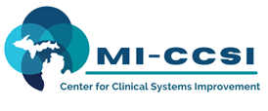

Michigan Center for Clinical Systems Improvement (Mi-CCSI)

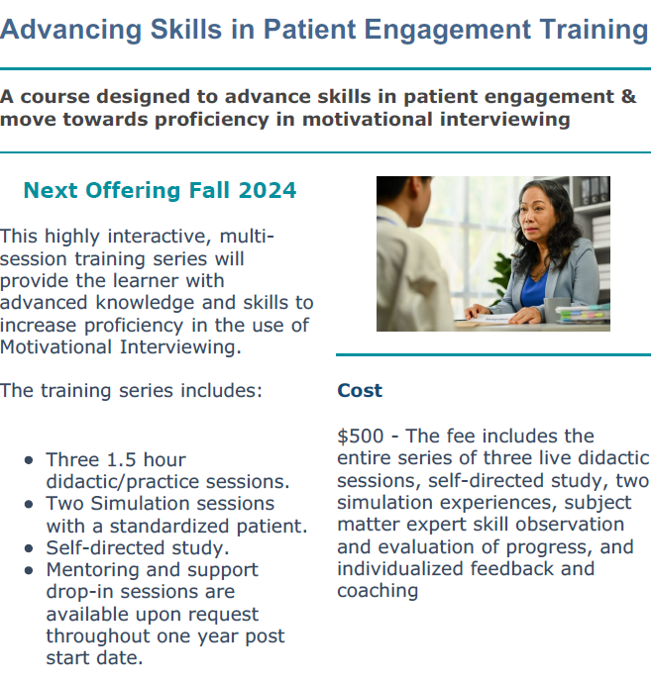

Learn More



LEARN MORE
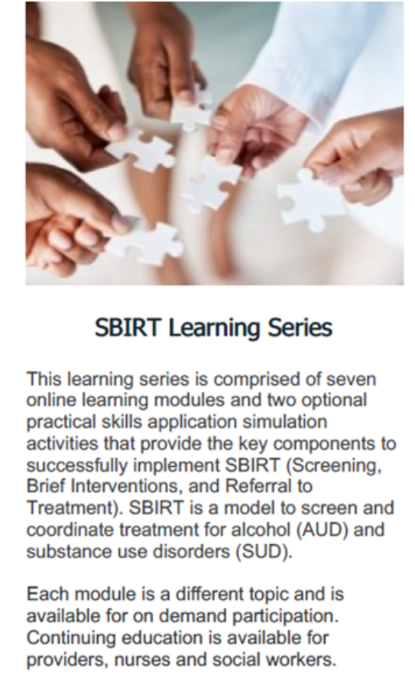
LEARN MORE

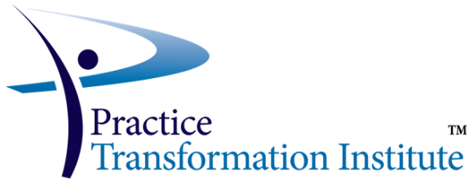

Practice Transformation Institute (PTI)

Introduction to Team Based Care
About this course:
The Introduction to Team-Based Care course helps the learner better understand how to work in a multidisciplinary care team and in collaboration with the patient. Open to all members of the practice to gain foundational knowledge in Team-Based Care.

Course Date and Time: (Live Virtual)

Monday, June 17, 2024, 8:00am-4:00pm Click here to register!
Wednesday, October 2, 2024, 8:00am-4:00pm Click here to register!

Patient Engagement
About the course:
The goal of this course is for all Care Team Members to learn engagement tools/skills in order to have productive conversations with patients about their health including basic motivational interviewing skills.

The Care Team Member will build upon this foundation, to utilize patient engagement skills in different situations such as Medication Assisted Treatment, (MAT) and Palliative Care.

It is strongly recommended to take Introduction to Team Based Care before taking this course.
For additional details, please visit https://micmt-cares.org/training/patient-engagement

Course Date and Time: (Live Virtual)

Monday, September 9, 2024 9:00am-4:00pm Click here to register!
Wednesday, December 4, 2024 9:00am-4:00pm Click here to register!

Foundational CM Codes and Billing Opportunities
About the course:
This course builds upon the Introduction to Team-Based Care course, focusing on reimbursement for care management services. The course is designed to support and train physician organizations and practice staff on care management billing.

Course Date and Time: (Live Virtual)

Tuesday, June 25, 2024 8:00am – 12:00pm Click here to register!
Wednesday, October 23, 2024 8:00am – 12:00pm Click here to register!

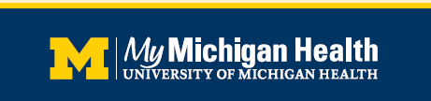

MyMichigan Health
Please join us for a

FREE Advance Care Planning Community Facilitator Training

Community Health Worker, Nursing and Social Work continuing education credits (CNEs)

Thursday August 29, 2024 | 8:30 a.m. - 12:30 p.m.

The training is in-person with a virtual option. Participants will either be emailed a link to the in-person location or virtual training upon registration.

Pre-work will be emailed to the participant at course sign-up. Pre-work and

participation in role plays are expected for this course.
Virtual attendees must have a working camera and microphone or ability to call in, as active participation is needed.

MyMichigan Medical Center Midland is an approved provider with the Michigan Social Work Continuing Education Collaborative. Approved Provider Number: MICEC-0043. Four Social Work CEUs are available upon successful completion of this four-hour program.

MyMichigan Health is accredited as a provider of nursing continuing professional development by the American Nurses Credentialing Center’s Commission on Accreditation. Three and a half contact hours are available upon successful completion of this four-hour program. In order to receive contact hours for this activity, you must stay for 90 percent of the course and complete an evaluation.

MyMichigan Health is an approved provider with Michigan Community Health Worker Alliance. Four CHW CEUs are available upon successful completion of this four-hour program.



Michigan Community Health Worker Alliance (MiCHWA)

MiCHWA offers an array of trainings throughout the year. Below is a list of our trainings scheduled for the rest of the year. Please check out our Training Schedule on our website for registration details. https://michwa.org/upcoming-training-certifications/?fbclid=IwAR1lZEe-odWk0zRfQ6gz4ebKBB1uTHjfUgcRI61o2sDkpz0WDsvukjDdujI

Community Health Worker Training Program

The curriculum is designed to train front-line health workers to provide culturally responsive services in Michigan communities. The 166 training hours includes 25 hours for independent self-study. Independent self-study ensures that the participants are given sufficient time to work on homework, quizzes, projects, and other assignments. Independent self-study hours may be completed at the participant’s home, work location, or other location.

As part of the 166 training hours, 40 internship hours are required, consisting of field experiences in local agencies where the focus is for the student to apply and integrate theory into practice. CHWs who are currently employed will complete the internship at their place of work.

Tuition varies by certification training programs and is set by the training organizations, not by MiCHWA.

Detroit Recovery Project Time: 8:30am-5:00pm Location: In-Person | Start date: July 16, 2024  End date: September 27, 2024
Henry Ford College Time: 8:30am-5:00pm Location: In-Person | Start date: September 3, 2024  End date: October 24, 2024
MiCHWA  Time: 9:00am-4:30  pm Location: Virtual | Start date: September 9, 2024  End date: October 30, 2024 Registration Opens: July 9,2024
Detroit Recovery Project Time: 8:30am-5:00pm Location: In-Person | Start date: September 16, 2024  End date: October 23, 2024
Henry Ford Health System Location: Virtual | Start date: November 4, 2024  End date: January 20, 2025

Foundations of Behavioral Health Micro-Credential

The Community Health Worker (CHW) Foundations in Behavioral Health is a 64-hour micro-credential that prepares CHWs to bridge gaps in behavioral health care and provide invaluable support to individuals in need. Upon successful completion, the student will receive a certificate for this micro- credential from MiCHWA. This training has a value of $600.

FBH  Time: 9:00am-4:30pm Location: Virtual | Start date: August 5, 2024  End date: August 29, 2024
FBH  Time: 9:00am-4:30pm Location: Virtual | Start date: November 4, 2024 End date: November 29,2024

Virtual classes will be held on Tuesdays and Thursdays from 9am-4:30pm.
This program is conducted virtually. It is an online synchronous model incorporating learn at your own pace modules as well as face to face Zoom meetings.

- Mental Health First Aid  - ACES – Adverse Childhood Experiences  - Eating disorders  - Violence prevention  - Stress management  - Substance abuse prevention | - QPR – Suicide Prevention  - Early childhood development  - Human trafficking  - Depression  - Racism’s impact on children and adolescents



Health Net of West Michigan

- Health Net of West Michigan provides facilitated training and curriculum packages that engage learners with practical expertise so that participants can apply session concepts and skills in their everyday work. We create a community of practice that leads to enhanced learning and collaborative relationships. All facilitated training sessions are approved for continuing education for community health workers (MiCHWA-approved) and social workers (NASW-MI approved).
- The Care Model© Training Series is a frontline navigator training that develops core skills for health and social service advocates. Participants build knowledge and competencies through interactive sessions where learners not only engage with the facilitator, but also with one another. The goal is to increase client engagement and community well-being through equitable access to resources. Frontline professionals like CHW’s, resource and referral specialists, case managers, and family support workers learn techniques and skills to effectively assist community members in connecting to the healthcare and social services systems. The series consists of seven topics chosen to address core competencies needed by frontline professionals. Register online! The next cohort begins June 24 in Grand Rapids, MI. Health Net is also available to bring Care Model Training to your organization or community.
- Health Net also offers licensed Care Model© Training Curriculum to support you in building capacity within your own teams.
- Health Net develops supervisors within the healthcare and human services fields because supervision is a key component to effective service delivery and staff engagement and retention. Supervisors can provide the structure, support, and guidance to the workforce that results in high quality services and increased job satisfaction, yet supervisors do not often receive the training they need to help them successfully lead a team. Supervision that achieves these results takes intentionality, skill development, and resources. Facilitated Supervisor Training is a peer-supported cohort that guides participants in developing their leadership approach, competencies, and confidence for supervision. Participants attain a toolbox of practical leadership skills that will guide them in their journey. Crafted by a team with extensive experience in the social services industry, this training series will help you better navigate the challenges of being a supervisor.
- Please reach out to Christina Pavlak, Vice President of Training & Development, about your training needs.

